Chapter 02 – Digital Image Fundamentals

Table of Contents

Light 2

Signals 4

Digital Image Acquisition Process 4

Sampling Rate 5

Quantization Levels 7

Image Formation Model 8

Illumination and Reflectance 8

Resolution 8

Relationships Among Pixels 9

Neighbours 9

Connectivity 10

Paths 10

Adjacency 11

Distance Measures 11

Operations 13

## Light

Human beings are only capable of seeing light in a narrow spectrum of the entire electromagnetic spectrum, from $0.43μm$ (violet) to $0.70μm$ (red). Light reflects off of different objects and is absorbed to some extent, losing energy. The energy that remains bounces off the objects and into our eyes, which is why we see objects with different colours.

Light that contains colour is said to be **chromatic**, which light that is void of colour is said to be **achromatic**. Achromatic light is just greyscale. Other attributes of light include:

* **Radiance** – The total amount of energy at the source of the light, measured in **watts** ($W$).
* **Luminance** – The amount of energy the viewer perceives, measured in **lumens** ($lm$).
* **Brightness** – This is a subjective descriptor and as such is basically impossible to measure. If we do want to measure it, we must measure it as intensity.

The last point is particularly interesting. At the point of an image where there is a drastic change in intensity (such as the edge of an object), our eyes tend to overshoot or undershoot the actual value of intensity, leading to a **staircase effect** as shown below.



This is what gives us various types of optical illusions.



We can manipulate this information to modify images. For example, we can increase the contrast around edges of objects to make them appear sharper or decrease it to make them appear blurred.

## Signals

We normally think of signals in the time domain, i.e., **time-varying** signals. However, signals for images work in the space domain, i.e., **spatially varying** signals. Basically, for a point $\left(x,y\right)$, the value of $f\left(x,y\right)$ is the intensity of the signal at that point. Some medical devices like CAT scanners can produce images that are 3D, i.e., $f\left(x,y,z\right)$. Videos can also be thought of as 3 dimensional in the sense that the third dimension is time, $f\left(x,y,t\right)$, which is a **spatio-temporal** signal.

In the real world, signals are said to be **analogue**, which means they can be infinitely precise. To capture this information in the **digital** world however, we can only store the information to a finite precision. Thus, if a signal has a continuous domain and range, it is analogue, and if it has a discrete domain and range, it is digital.

## Digital Image Acquisition Process

To capture the information from a real image digitally, we rely on a light source emitting light, that light reflecting off an object and then falling on a sensor which converts the analogue signals to digital ones.

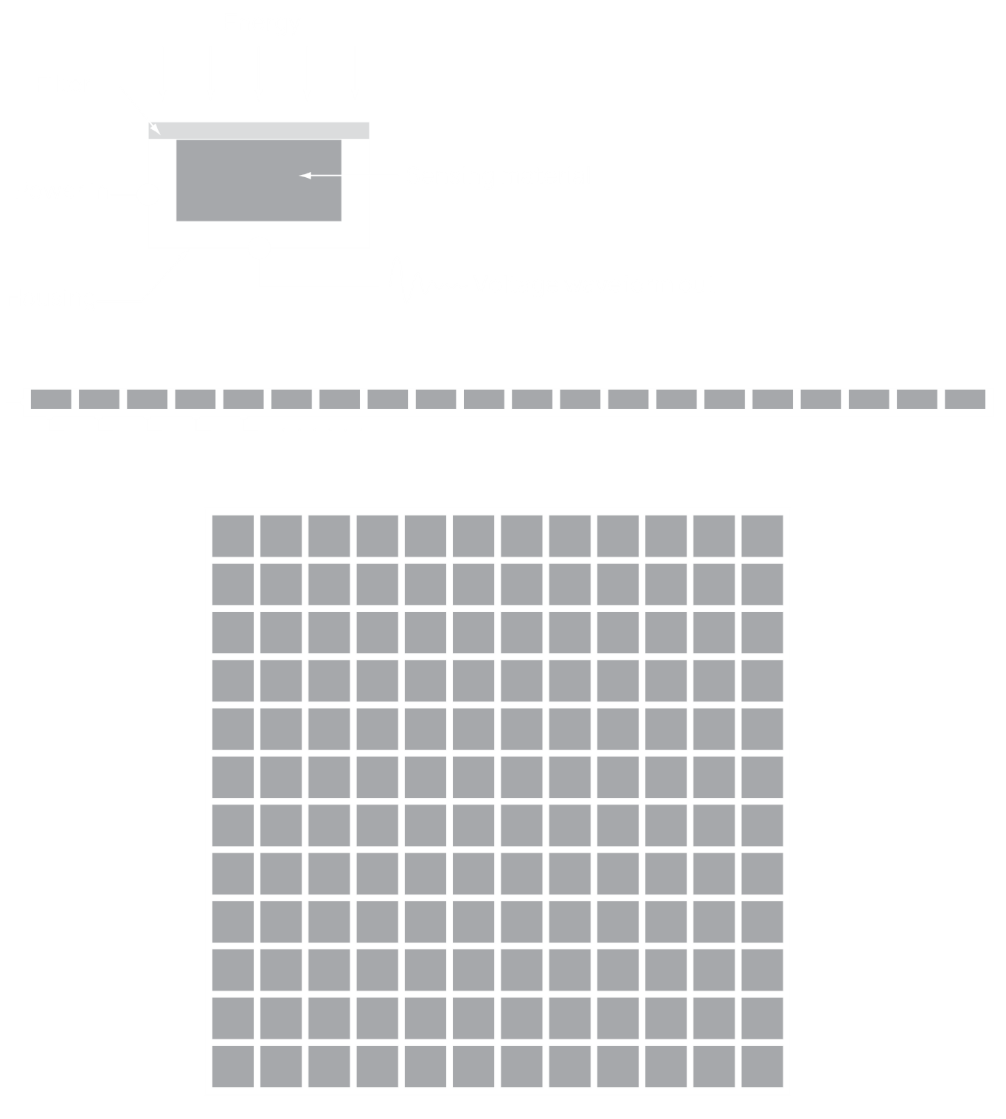

The sensors make use of two concepts to perform the conversion, sampling, and quantization. Both concepts directly affect the quality of the digital image produced.

### Sampling Rate

The **sampling rate** determines how often the sensor takes samples of the input signal. The analogue input signal is quite literally constantly sending a signal, but the sensor can only capture it at specific moments of time. If we try to capture all of the signal, we will have an infinitely large image. The more samples we take, the better the resolution of the image.

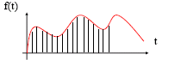

Since sampling affects resolution, if we capture the same image at a lower sampling rate and zoom in, we will see a **pixelation effect**.

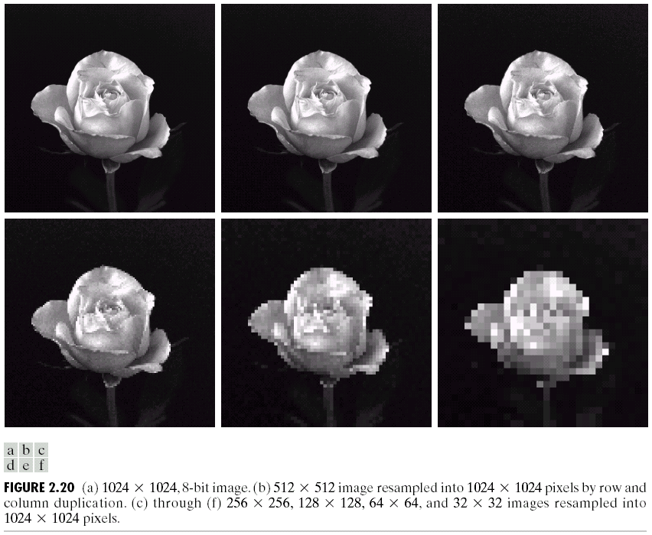

This effect is reduced in modern images using **interpolation**, which is basically averaging. Instead of duplicating pixels when zooming in (like above), we can take the average of neighbouring pixels to approximate the value of a ‘missing’ one. There are two types of interpolation, bi-linear, which takes the average of 4 pixels surrounding the ‘missing’ pixel, or bi-cubic, which takes the average of 16 pixels surround the ‘missing’ pixel.

### Quantization Levels

The **quantization levels** determine how accurately the samples we are taking will be able to represent the real image. Basically, the analogue input has an infinite number of shades in it. If we want to store this information, we need to define the number of shades we want to keep and place the captured information in those levels based on it.

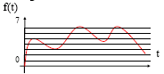

The result of lowering the number of quantization levels can be seen in the images below. The lower we go, the more prominent the changes in shading become.

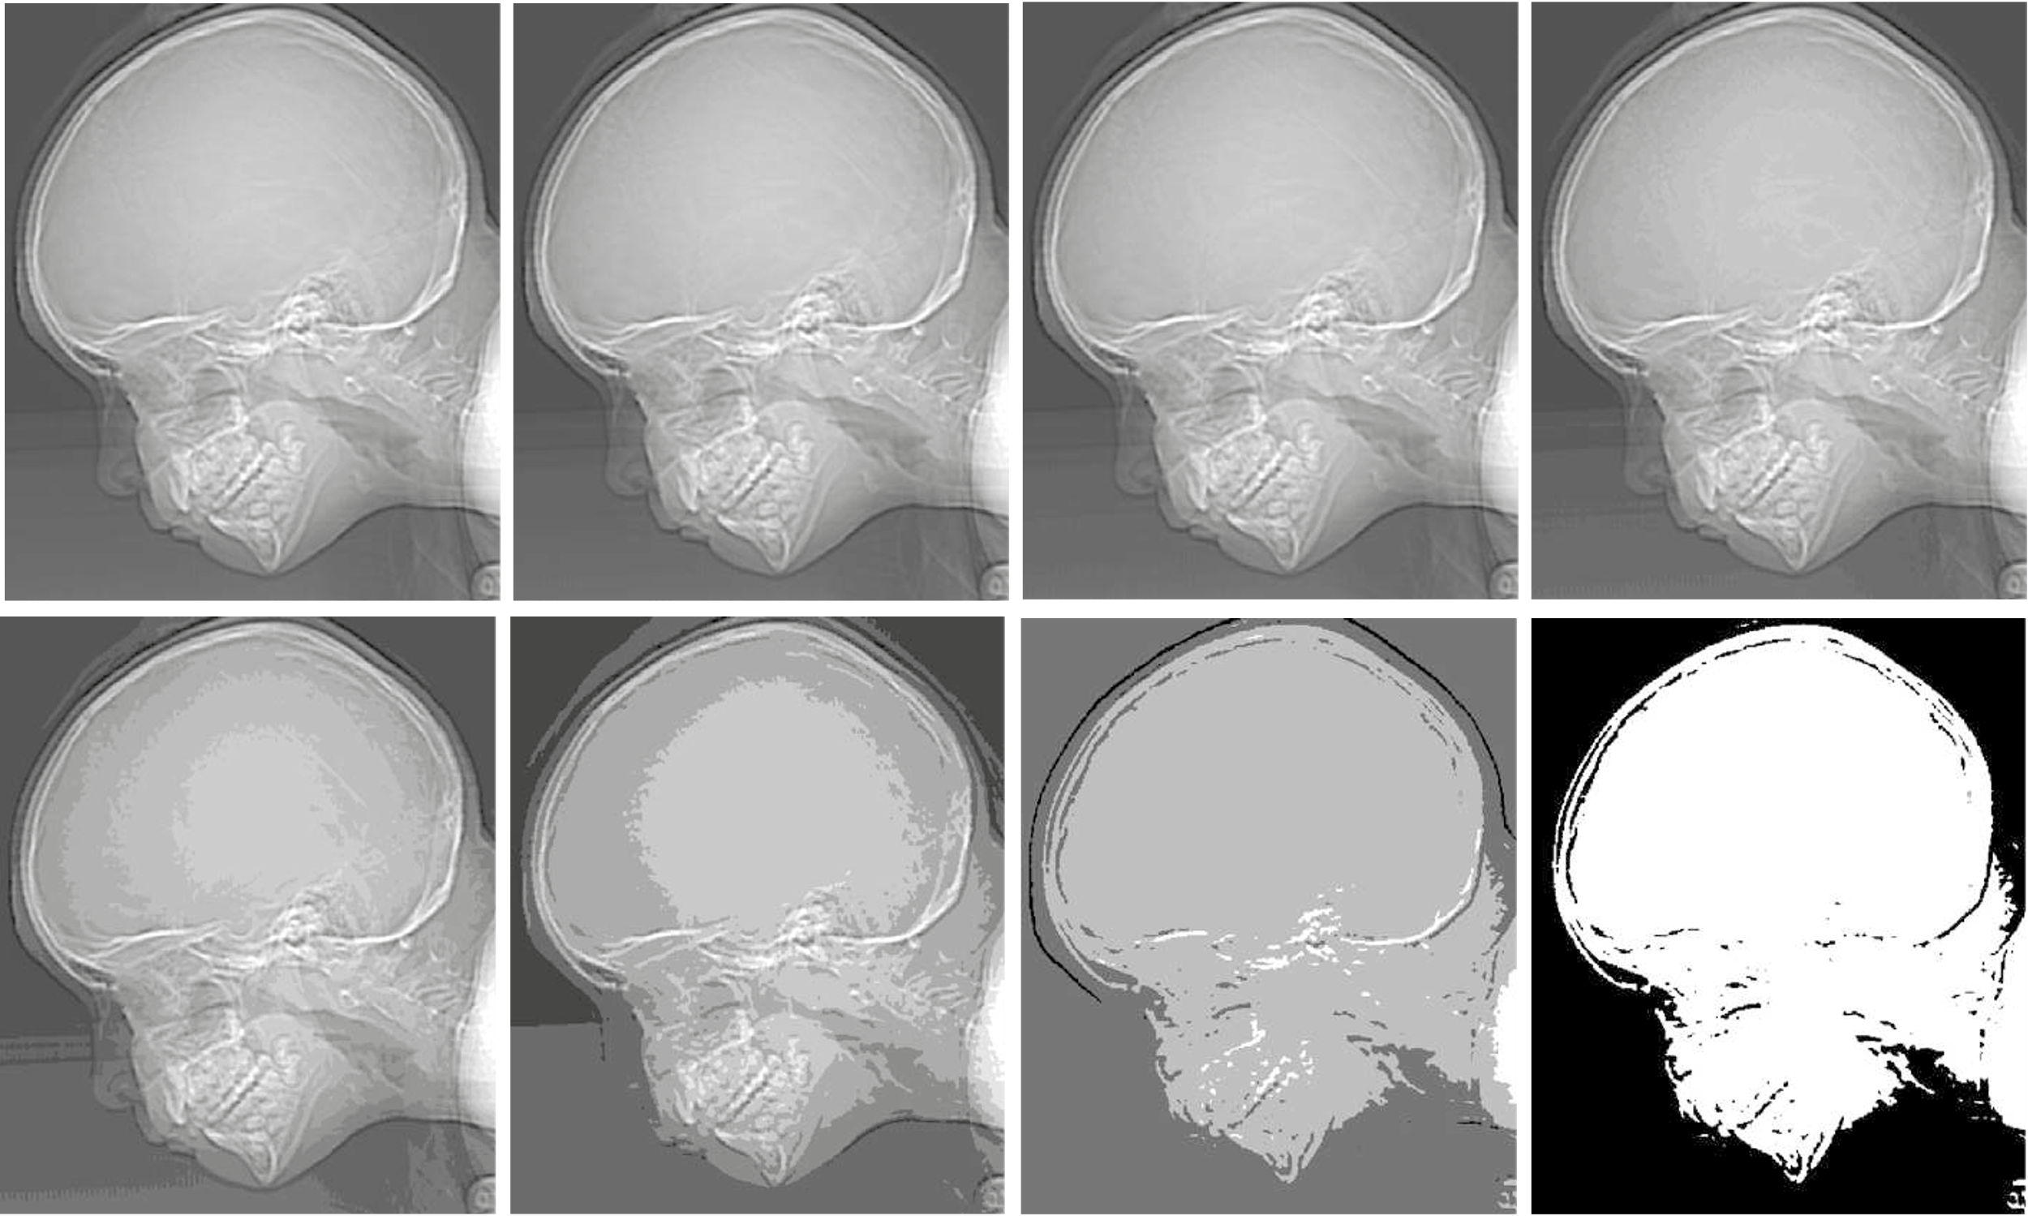

The effect of too few quantization levels, as shown above, is called **false contouring**.

## Image Formation Model

### Illumination and Reflectance

Since light is a form of energy, the value of any point $f\left(x,y\right)$ must be between $0$ and $∞$. This value depends on two things, the **illumination** of the light source, $i$, and the **reflectance** of the object, $r$. Illumination is bounded to $0$ and $∞$, while reflectance determines how much of the original light is reflected, and thus has a value between $0$ and $1$. Thus, $f\left(x,y\right)=i\left(x,y\right)r\left(x,y\right)$.

#### Grey Levels

For a **monochrome image**, the intensity at a point $f\left(x,y\right)$ is called the **grey level** at that point, denoted by $l$. This value is between $L_{min}$ and $L_{max}$, and is typically shifted to be between $0$ and $L-1$, where $0$ corresponds to black and $L-1$ corresponds to white. The range covered by the grey levels is informally called the **dynamic range**.

### Resolution

The **resolution** of an image depends on the sampling rate ( $M$ in one dimension and $N$ in the other dimension) and the grey levels ($k$). However, this also affects the size ($b$) of the image.

$$b=M×N×k$$

Due to storage and quantization hardware limitations, the number of intensity levels ($L$) is typically a power of $2$, i.e. $L=2^{k}$.

**Spatial Resolution** measures the smallest discernible detail of an image. It is measured in line pairs per unit distance or dots (pixels) per unit distance (DPI).

**Intensity Resolution** measures the smallest discernible change in intensity level. It depends on the number of bits used to quantize the intensity.

## Relationships Among Pixels

### Neighbours

We can refer to the neighbours of a pixel in 3 ways, $N_{4}\left(p\right)$, which refers to the neighbours on the 4 sides, $N_{D}\left(p\right)$, which refers to the neighbours on the 4 diagonals, and $N_{8}\left(p\right)$, which refers to all 8 neighbours.

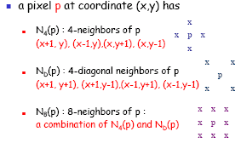

### Connectivity

Connectivity is defined in one of three ways based on the neighbours.

* A **4-connectivity** occurs between two pixels $p$ and $q$ if $q$ is within $N_{4}\left(p\right)$.
* An **8-connectivity** occurs if $q$ is within $N_{8}\left(p\right)$.
* A **mixed connectivity** occurs if $q$ is either in $N_{4}\left(p\right)$ or if it is in $N_{D}\left(p\right)$. The latter case can only be considered if we know that $N_{4}\left(p\right)$ is empty.

### Paths

A **path** is a sequence of pixel points including the start point $p$ and the end point $q$.

An 8-connectivity can cause issues with multiple paths being available when trying to define a path, as shown below. In this case, we should consider a m-connectivity since it solves the issue.

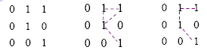

We can define 4-, 8- or m-paths depending on the **adjacency** type.

### Adjacency

Two pixels $p$ and $q$ are said to be adjacent if they are **connected**.

Two image area subsets $R_{1}$ and $R_{2}$ are said to be adjacent if some pixel in $R_{1}$ is adjacent to some pixel in $R_{2}$.

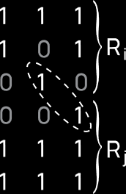

### Distance Measures

For three pixels $p$, $q$ and $z$, a function $D$ is a **distance metric** if:

* $D\left(p,q\right)≥0$ and $D\left(p,q\right)=0$ if $p=q$

$D\left(p,q\right)=D\left(q,p\right)$

$D\left(p,z\right)≤D\left(p,q\right)+D\left(q,z\right)$

There are multiple distance metrics.

The **Euclidian** distance metric measures the shortest distance between two points.

$$D_{e}\left(p, q\right)={\left[{\left(x_{p}-x_{q}\right)}^{2}+{\left(y_{p}-y_{q}\right)}^{2}\right]}^{\frac{1}{2}}$$

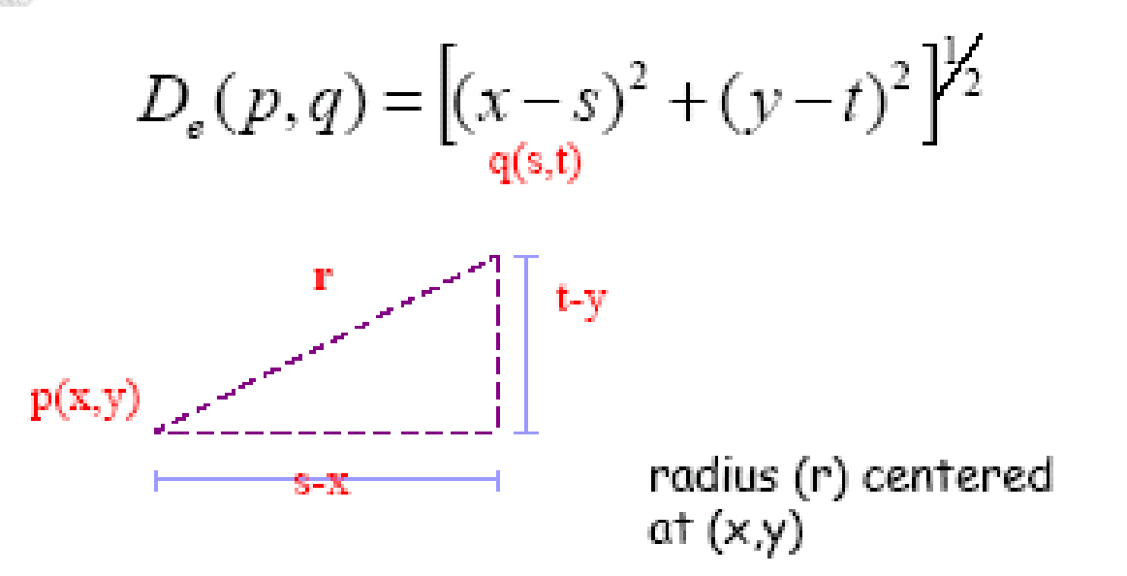

The **City-Block** distance metric measures distance as a diamond centred at $p$.

$$D_{4}\left(p,q\right)=\left|x_{p}-x_{q}\right|+\left|y_{p}-y_{q}\right|$$

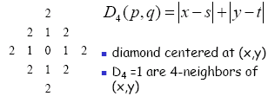

The **Chessboard** distance metric measures distance as a square centred at $p$.

$$D_{8}\left(p,q\right)=\max\left(\left|x_{p}-x_{q}\right|,\left|y_{p}-y_{q}\right|\right)$$

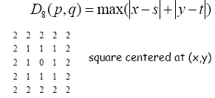

The **M-Connectivity** distance metric depends on the values of pixels. The examples below only consider distances between pixels $p$ and $p_{4}$ following paths that are connected via 1s.

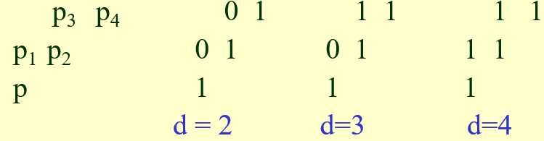

### Operations

An operator $H$ is said to be **linear** if it satisfies the following equation pixel by pixel for all pixels for two images $f$ and $g$. The values $a$ and $b$ are some scalar value.

$$H\left(af+bg\right)=aH\left(f\right)+bH\left(g\right)$$

Any operator that fails this test, e.g., $\left|af-bg\right|$, is said to be **non-linear**.

Arithmetic operators such as $+$, $-$, $×$ and $÷$ work with images of the same size.

Logical operators like union, intersection and complement work with the 1s and 0s of binary images.

